PAGE FEES

Title/reference for the article:

Author/s title, initials and surname:

Author/s affiliation and address

Author/s email:

Pages:

Total:

For scientific research articles, page fees of R350.00 per page will be charged from the South African author’s university. However, in the end it remains the responsibility of the author to ensure that these fees are paid.

Kindly provide evidence of the page fee payment before the publication of Yesterday & Today.

Yours

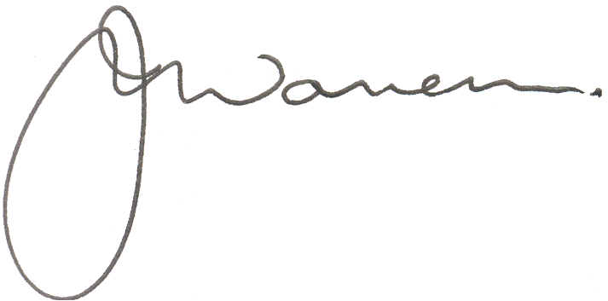

Prof JM Wassermann
Editor-in-Chief – Yesterday & Today

